Introduction

3V3 LDO is required to power analogue circuits due to 3V3 SMPS having too high output ripple. LDO current capability has been calculated in 3.3V domain power consumption.xlxs document. Part number for the LDO has also
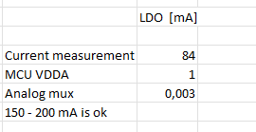
Figure 1 Current requirement calculation

Circuit design

LDO circuit is designed after manufacturers typical application circuit and it has already been verified on other projects.
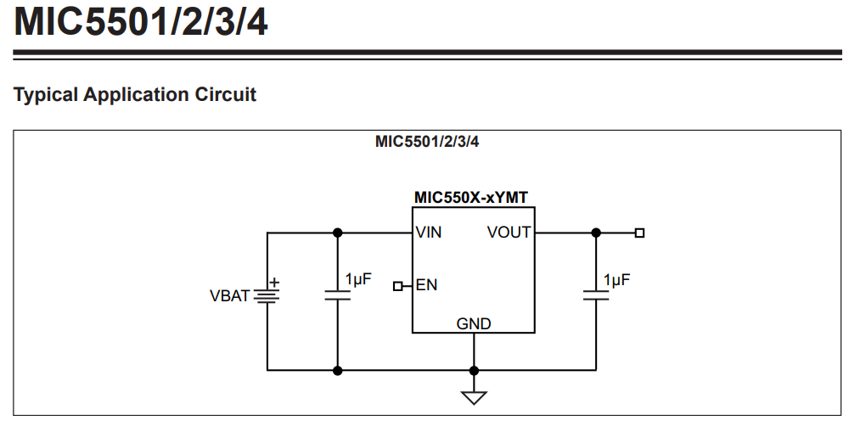
Figure 2 LDO manufacturers typical suggested circuit

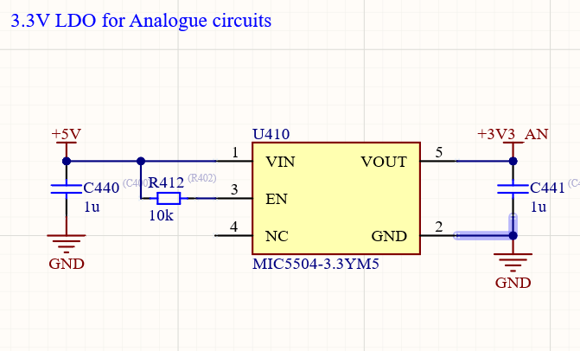
Figure 3. LDO implementation in the project

